OSSP SKILL 3
M. YASHWANT RAJ
ROLL NUMBER : 2520030181

3) HISTORY_SHELL.C
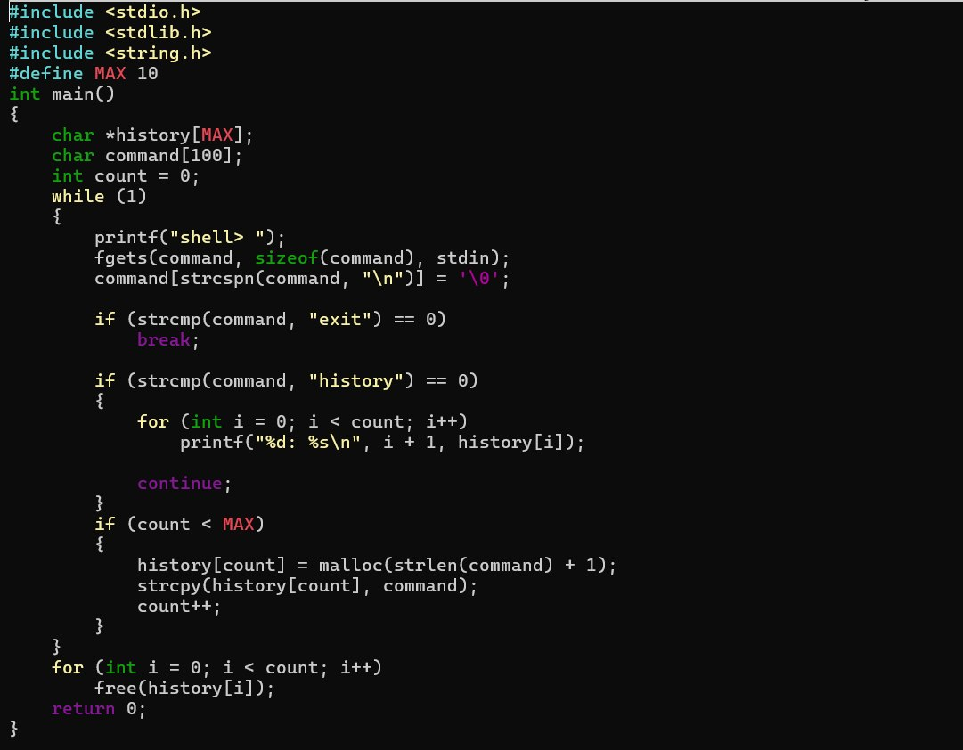
Output :
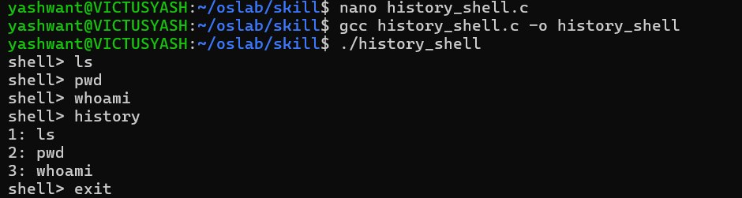

4) TOKENIZATION.C
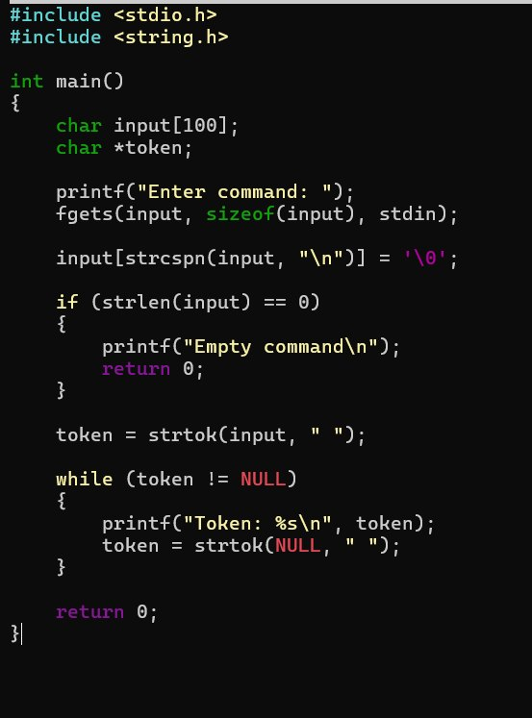

OUTPUT :
